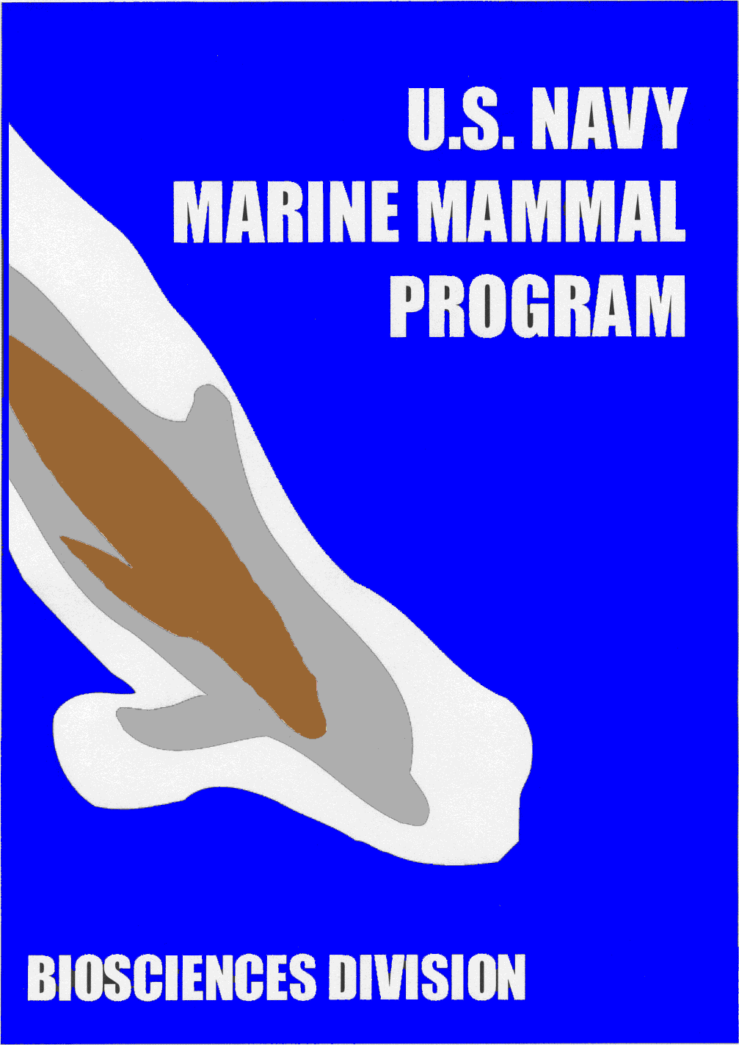

Veterinary Medical Externship

**Navy Marine Mammal Program**

**NIWC Pacific, San Diego, CA**

Navy Marine Mammal Program History

The US Navy’s work with marine mammals began in the late 1950s. By understanding how dolphins move in the water, the Navy hoped to improve torpedo, ship, and submarine designs. Soon the Navy realized that dolphins would also be valuable assistants to Navy divers working in the open ocean. Unlike human divers, dolphins are capable of making repeated deep dives without experiencing “the bends.” They also found that dolphins and sea lions are highly reliable, adaptable, and trainable marine animals that could be trained to search for, detect, report, and mark the location of objects in the water.

Over the years, the program has expanded and changed to meet the dynamic challenges of modern National defense requirements. The development, training, veterinary care, and research facility that supports today’s Navy Marine Mammal Program (MMP) is centered at NIWC Pacific on San Diego Bay.

In the course of the development of this program, Navy scientists established themselves as pioneers in the study of marine mammals. This tradition continues today at the San Diego facility with studies in acoustics, marine mammal husbandry and medicine, and sound and contaminant pollution. Using advanced technology and diagnostics, the MMP is developing improved protocols for maintaining the health and well being of the animals. As part of the team, animal trainers diligently strive to continually improve care and management practices that benefit not only the Navy’s marine mammals but also those in other marine mammal facilities and stranding centers.

# VETLAB

Mission Statement: Protect the Navy’s marine mammals by providing the finest possible veterinary care through continued improvement in knowledge, diagnostics, equipment and methodology.

The VETLAB staff provides on-call veterinary care 24 hours a day, 7 days a week. Mornings are used for scheduled clinical procedures, veterinary medical technologies support, and rounds. Most afternoons are dedicated to sample processing, data entry, research, training, and unscheduled (urgent) procedures. Students are given the opportunity to observe and participate in all clinical activities, under the direction of the veterinary staff, as the situation permits. In addition, students are expected to select and complete a clinical project in marine mammal medicine while on-site.

The MMP maintains and cares for a large population of dolphins and sea lions in an open-ocean environment in San Diego Bay. Student externs are given the unique opportunity to observe and contribute to the preventive medicine program that includes:

1. Regularly scheduled comprehensive physical examinations
2. Nutrition and sanitation oversight
3. Veterinary medical data management and biologic specimen archival
4. Veterinary support of animal deployments
5. Advanced clinical technologies development
6. Staff development regarding animal care

# Requirements and Student Selection

Four to six students are chosen each year to participate in a four-six week externship. Only one student will be on-site at a time. Students are encouraged to participate in the externship during their senior level or fourth year at an accredited veterinary college. Applicants must provide proof of United States citizenship.

The VETLAB preceptorship program is a non-funded program. However, students are required to make a full-time commitment during their term with the MMP. In addition, students are responsible for their own transportation and housing arrangements.

# How to Apply

Interested students should submit a letter of intent indicating their interest in the MMP Veterinary Medical Externship. This letter should include reasons for wanting to participate in the program, and dates of availability. It is recommended that applicants list at least three prioritized availability dates. In addition, students must submit a CV, three letters of reference, and proof of US citizenship. All application materials should be emailed to Erika Putman at nmmp_intern@spawar.navy.mil by **November 1st of their 2nd year for dates within their 4th year.**.