-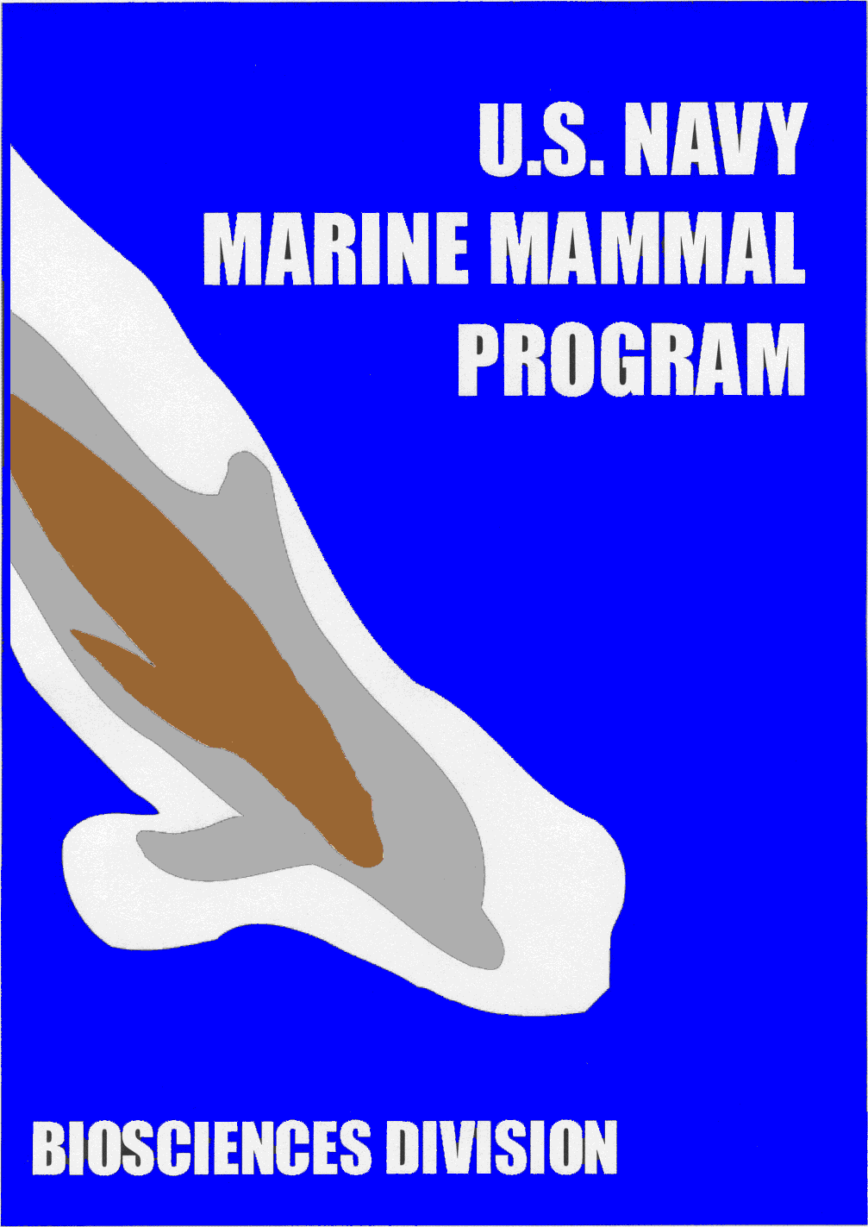

Navy Marine Mammal Program

Animal Care & Training Internship

The Navy Marine Mammal Program (MMP) began in 1959 with a single Navy scientist and one dolphin. Since that time, the program has expanded its study with the development of the Fleet Marine Mammal Systems utilizing dolphins, beluga whales, and sea lions. In addition, the MMP is doing a variety of research projects investigating the hearing abilities in a number of species of marine mammals. Research studying dolphin’s biosonar, and their physiological environmental adaptations are also being conducted. We are currently offering positions to be a part of the marine mammal program through internship opportunities.

This internship is designed to give undergraduate students a dynamic educational experience in the marine mammal field while offering valuable career experience. Students will be responsible for a number of support tasks with dolphins and sea lions throughout the course of the internship. These responsibilities will include diet preparation, sanitation, and equipment and facility maintenance. Interns may also have the opportunity to assist the marine mammal training staff in husbandry and open ocean training. In addition, they will provide support to the animal care staff in animal physicals, and assist in a number of different marine mammal research projects. Lectures and field trips will also be conducted throughout the term to enhance the learning experience.

The internship is offered on a competitive basis to sophomores, juniors, and seniors in the Marine Science, Biology, Zoology, Psychology, and Veterinary fields. Though the internship is designed for undergraduate students, recent graduates are also eligible to apply. All interns must arrange to receive college credit to be considered for the internship. The internship is a 40 hours per week, 16-week commitment. Interested students are encouraged to send a resume, cover letter, an unofficial or official copy of their transcripts, proof of medical insurance, and proof of US citizenship. In addition, a minimum of three letters of recommendation from professors or employers is necessary to complete the application. The application deadline for spring is October 1st, summer is March 1st, and Fall is June 1st. As of January 2022, all interns participating in the program must be fully vaccinated for covid. Please email all application materials directly to Erika Putman at nmmp_intern@spawar.navy.mil.

If you would like to learn more about the MMP, we encourage you to visit our website at https://www.niwcpacific.navy.mil/marine-mammal-program/. If you have any further questions, please feel free to contact Erika Putman at (619) 767-4100, or email at nmmp_intern@spawar.navy.mil.